Microbiology
Lab 9

DNA Extraction and Agarose Gel Electrophoresis to Separate DNA Molecules

Virtual DNA Extraction

Watch this short video https://youtu.be/usaE_XZx-a8

Follow along the DNA extraction virtual lab at the following URL

http://learn.genetics.utah.edu/content/labs/extraction/ and answer the questions on the report pages.

Agarose gel Electrophoresis

Background

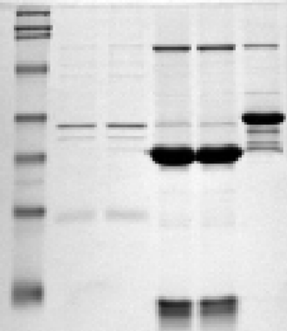
Electrophoresis is a technique used to separate macromolecules that differ in size, charge or conformation using an electrical field. It is one of the most widely used techniques in biochemistry and molecular biology. For example, agarose gel electrophoresis is the easiest and commonest way of separating and analyzing DNA. The purpose of the gel might be to look at the DNA, to quantify it or to isolate a particular band. Polyacrylamide gel electrophoresis is used most often to separate and analyze proteins. The purpose of this type of gel might be to separate proteins from a mixture for analysis or identify and quantify a particular protein.
DNA, RNA, and proteins can be separated using gel electrophoresis because they are highly charged molecules, come in different sizes and will move in an electrical field. DNA and RNA, because of their phosphate groups, are normally very negatively charged molecules. Amino acids, on the other hand, can be negatively charged, positively charged, or have no charge. Therefore, depending upon the different kinds of amino acids found in a particular protein, proteins can have an OVERALL negative charge, an OVERALL positive charge, or have the same amount of - and + amino acids and be neutral. When placed in an electrical field, molecules with positive charges move to the negative electrode, while molecules with negative charges move toward the positive electrode thus separating molecules positive molecules from negative ones.
Nucleic acids and proteins also come in different sizes. The size of a protein is measured in daltons and is usually portrayed in terms of kilodaltons or kd. A dalton is equal to the mass of one hydrogen atom. Therefore, one kilodalton has the same mass as 1000 hydrogen atoms. So, a 50 kd protein has the same mass as 50,000 hydrogen atoms. DNA and RNA are usually measured in terms of the number of base pairs in the molecule. A 1000 bp or 1kb (kilobase) piece of DNA contains 1000 base pairs. The same unit of measure is used for RNA.
When a mixture of different size molecules are exposed to an electrical field the larger ones move slower than smaller molecules. As these molecules migrate through a matrix being driven by their charge and an electrical field, larger molecules move slower than smaller ones and thus separate out from each other. This creates bands of molecules of different sizes in the get matrix.
Proteins and nucleic acids are electrophoresed within a matrix or "gel". Most commonly, the gel is cast in the shape of a thin slab, with wells for loading the sample. The gel is immersed within an electrophoresis buffer that provides ions to carry a current and some type of buffer to maintain the pH at a relatively constant value. The gel itself is composed of either agarose or polyacrylamide, each of which has attributes suitable to particular tasks.
Polyacrylamide is commonly used to separate proteins. It is a cross-linked polymer of acrylamide. The length of the polymer chains is dictated by the concentration of acrylamide used, which is typically between 3.5 and 20%. Polyacrylamide gels are significantly more annoying to prepare than agarose gels. Because oxygen inhibits the polymerization process, they must be poured between glass plates (or cylinders). Also, acrylamide is a potent neurotoxin when it is in liquid form. Once it is polymerized it is safe.
Agarose is used to separate different size fragments of DNA. It is a polysaccharide extracted from seaweed. It comes in a powdered form and is insoluble in water (or buffer) at room temperature. But it dissolves in boiling water. When it starts to cool, it undergoes what is known as polymerization. Rather than staying dissolved in the water or coming out of solution, the sugar polymers crosslink with each other, causing the solution to "gel" into a semi-solid matrix much like "Jell-O" only firmer. It is typically used at concentrations of 0.5 to 2% - the higher the agarose concentration the "stiffer" the gel.
Unlike acrylamide, agarose is non-toxic. Agarose gels have a large range of separation, but relatively low resolving power. By varying the concentration of agarose, fragments of DNA from about 200 to 50,000 bp can be separated using standard gel electrophoresis techniques.
Agarose gels are extremely easy to prepare you simply mix agarose powder with buffer solution then melt it by heating. While the solution is still hot, you pour it into a mold called a "casting tray" so it will assume the shape we want as it polymerizes (otherwise it will just solidify in the bottom of the flask wasting the expensive agarose).
Samples are prepared for electrophoresis by mixing them with solutions that contain glycerol or sucrose making the sample denser than water. Samples are “loaded” into wells created in the gel by a template during casting. The dense samples sink through the buffer and remain in the wells.
The electrophoresis chamber containing the gel is filled with buffer. The buffer serves as a conductor of electricity and to control the pH. This is very important since pH has an effect on the charge and stability of biological molecules. To get the molecules to move, a power supply is connected to the electrophoresis chamber and current is applied. Charged molecules in the sample enter the gel through the walls of the wells. Molecules having a net negative charge migrate towards the positive electrode while the net positively charged molecules migrate towards the negative electrode. Also, smaller molecules will move faster than larger ones. This effectively separates molecules from each other.

Do the following agarose gel electrophoresis interactive lab from the following link

https://learn.genetics.utah.edu/content/labs/gel/

Read the following article and write a reflection on new insights and lessons you gained from the reading.

Can DNA Demand a Verdict? From the following link

https://learn.genetics.utah.edu/content/science/forensics/

Microbiology
Lab 9 Report Name ___________________

DNA Extraction and Agarose Gel Electrophoresis

Virtual DNA Extraction Interactive

1.What are three ways human DNA can be used?

2. Where is DNA located? How much DNA can be found in one cell?

3. What kind of cells can be used to isolate DNA?

4. What are the four steps to purify DNA?

5. What are some reagents used in the DNA purification?

6. What is the purpose of the lysis solution?

7. What is the purpose of the salt solution?

8. What can you do with DNA once it is extracted from a cell?

Virtual Gel Electrophoresis Questions be sure to read the background on agarose gel electrophoresis or go back to it to find answers to the questions below

Can DNA Demand a Verdict?

Go through https://learn.genetics.utah.edu/content/science/forensics/

Write a reflection of what you learned from above

Refection on DNA and forensics

The following questions pertain to agarose gel electrophoresis and DNA and Protein separations

Answer the following questions on agarose gel electrophoresis:
1. What three properties of molecules are used to separate them using agarose gel electrophoresis?

2. Explain why DNA normally moves toward the positive electrode during electrophoresis.

3. If a mixture of different size DNA fragments is placed into the well of an agarose gel and a current is applied, what will happen? Explain why.

4. What is the purpose of the agarose?

5. Why is glycerol added to samples before they are loaded into the wells? Why is this important?

6. The following picture shows the DNA electrophoresis of samples A, B, C run along with the bp ladder markers which show the relative position of the markers in the gel.

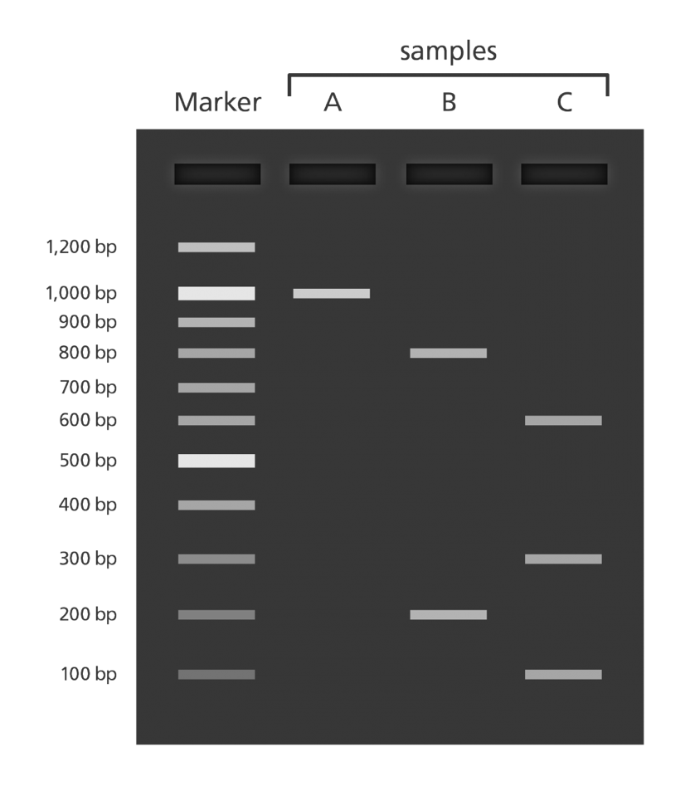

For the gel shown above which is the positive side of the gel?

7. For samples A, B, and C indicate the sizes of the DNA bands

Sample A:

Sample B:

Sample C:

8. Note that proteins can also be used in electrophoresis to separate the different size fragments.
Proteins can be positively or negatively charged and can be placed in wells that are in the center of a gel. Predict on the gel below where the following proteins will migrate after an electrical current has been applied
(Hint: proteins will move in the direction opposite their charge).

Draw the movement of the following on this gel, take a picture and insert the picture back in this document.

been applied. Lane 1 2 3 4
Size Charge +
Lane 1: Protein A 34,000 daltons +
Lane 2: Protein B 67,000 daltons +
Lane 3: Protein C 13,000 daltons +
Lane 4: Protein D 13,700 daltons -

-

Add your picture here:

9. Can DNA demand a verdict? Write your reflection and take away from this article below

